**Policy Video Script**

|  |  |
| --- | --- |
| **Speech** | **Image** |
| To fight climate change and avoid an ever-warming climate, we need an array of policies. Climate policies are needed | Curve of temperature is rising, then an item appears and blocks its further increase, then the curve continue to be drawn but flat. This item is a barred red circle inside of which there is a plane and a car with smoke/pollution. |
| to transform the way we produce energy, to make buildings greener, to put greener cars on the roads and reduce our fuel consumption. But these policies also need to protect people’s jobs and incomes. Let’s have a closer look on three possible climate policies. | Each corresponding item appears when its name is pronounced: a wind turbine below a crane, a barred red circle with polluting car, a person with a gallon of oil in one hand and cash in the other where size of gallon diminishes and cash grows. |
| Let’s start with a policy that forces car producers to produce greener cars - an *emission* *limit for cars*. | Shows a barred red circle inside of which there is a car with smoke/pollution. |
| With an emission limit, car producers are required by law to produce cars that emit less CO2 per **kilometre**. The emission limit is lowered every year, with the aim that only electric or hydrogen vehicles will be sold after 2040. Note that electric vehicles can be more expensive than cars that run on petrol. | Show a car with smoke/pollution next to a factory, then a bill of law with “max 95 gCO2/km [\newline] 2021” written, then the smoke diminishes, then the text becomes “max 60 gCO2/km [\newline] 2030” and the smoke diminishes further, then “only electric [\newline] 2040”, the smoke disappears and an electric plug appears on the car |
| Together with a plan to produce electricity from clean sources, **an emission limit** would accomplish the transition needed in the car industry. | The electric car, a sign “+” and wind panels, a sign “=” and a thumb up |
| Now, let’s turn to a policy that combines a tax on carbon emissions to reduce emissions and cash transfers to protect people’s **income**. | Shows the person with a gallon of oil in one hand and cash in the other where size of gallon diminishes and cash grows. |
| With a carbon tax, all products that emit greenhouse gases would be taxed. For example, the price of gasoline would increase by **8 rupees per liter.** | A person fills up her gas tank. The price of gasoline is displayed, and it goes up. |
| With a carbon tax, companies and people pay for the greenhouse gases they emit. This pushes them to reduce their emissions. | The person walk away from her car and takes a bicycle. |
| To compensate people for **higher prices**, the revenues of the carbon tax would be redistributed to all households, regardless of their income. Each adult would thus receive **6000 rupees per year**. | Shows a balance with on one side two barrels of oil and on the other side a pile of cash. **“+ 3000₹”** appears within each barrel so the balance tilts on the barrel side, then new cash comes on the pile with “+3000₹” above and the balance tilts very slightly towards cash [figures to be adjusted]. Next to the balance is a normal person (e.g. woman in a dress). |
| On average, poorer people own smaller cars, live in smaller houses and fly less, so they use less fossil fuels than average. As they would receive the same cash transfer as everyone else, poorer people will generally gain from a carbon tax with cash transfers. Conversely, rich people will tend to lose. | The person is now a blue collar. Shows the same balance as before with one less barrel: now the balance clearly tilts towards cash. |
| *Does this policy work? Yes! The Canadian province of British Columbia has a carbon tax with cash transfers since 2008. Research has shown that this policy has decreased carbon emissions, increased employment, and made a majority of people richer.* | *Shows a map of Canada with inside a car with diminishing pollution, 3 blue collars holding cash that turn 4 then 5 blue collars holding more cash (they don’t smile)* |
| The last policy is a large program of public investment in green infrastructure, | Shows a wind turbine below a crane. |
| which would be financed by additional debt taken up by the government. | Shows cash transiting from a bank and the government coffers to the wind turbine/crane. |
| A green infrastructure program would bring about the transition in energy infrastructure needed to halt climate change. In India, 2.3 million of people could find a job in green sectors, such as public transportation, renewable power plants, buildings’ insulation, or sustainable agriculture. | Show a blue collar next to the wind turbine, then also a person in a bus, then also a construction worker near a building, then also a farmer in a field. |
| *In general, all climate policies have the potential to transform the economy into a greener, safer, less polluted world. This green transformation has some downsides: people will have to change their habits, and some people will even have to change job.* | *Shows a factory / coal power plant, a polluting car and a coal miner, then an arrow, then a wind turbine, a bicycle and a construction worker.* |
| *For example, there will be less demand for polluting sectors such as coal mining. But re-training options would be offered to workers in these sectors to ensure that they could find a new job elsewhere.* | *Shows a coal miner next to the other (but a bit farther away), his helmet switches from mining helmet (with lamp) to construction site helmet and his pick-axe switches to a hammer. (i.e. the coal miner becomes a construction worker)* |
| *And the green transition also comes with benefits: a safer world for future generations of course, but also less pollution. And climate policies can be designed to protect poor and middle-class households, as they can have more income with the carbon tax with cash transfers, and more jobs with a green infrastructure program.* | *On the right side of the arrow, add several blue collars holding cash.* |
| *We have focused on three important policies, but many others would be useful to fight climate change, including funding research into green technologies, subsidising the insulation of buildings, or stopping deforestation. To stop climate change, we probably need all of them together.* | *Shows a green light bulb, construction to repair a roof, and a growing tree.* |

**Climate Video Script**

|  |  |
| --- | --- |
| **Speech** | **Image** |
| In the past decades, humans have been burning more and more fossil fuels like coal, gas or oil. Burning fossil fuels releases CO2 in the atmosphere. | Graph (if possible, animated) of historic CO2 concentration, next to polluting cars (cars with smoke), planes, and coal power plants / factories (e.g. using <https://www.temperaturerecord.org/> ) |
| Today, the concentration of CO2 in the atmosphere is higher than any time over the last 800,000 years. | Unzoom to show graph of concentration over 800,000 years |
| Climate scientists agree: it’s the accumulation of greenhouse gases like CO2 released by human activity into the atmosphere that increases temperatures and causes climate change. | Show graph of temperatures (e.g. using <https://www.temperaturerecord.org/> ) |
| A rapid transition away from fossil fuels is technically feasible and could contain the global increase in temperature to **2°C**. | Extends graph of temperatures with 2°C scenario (e.g. using the figure below), and some wind turbines and trees on the side |
| But if greenhouse gas emissions continue on their current trend, the rise in global temperature will **be 4°C in 2100 and 7°C in 2200**. | Keep previous graph but adds a +4°C scenario (e.g. using the figure below), and on the side now there is a polluting car and a coal power plant / factory |
| *This may seem far away, but we can already feel the climate change consequences as heat waves, droughts and other disasters intensify. Air pollution caused by the burning of fossil fuels is already responsible for 6 million annual deaths worldwide.* | *Shows a skull with “6,000,000”, then a desert with a shrub drying.* |
| Here are some of the impacts expected by scientists in the absence of ambitious action to halt climate change: | The thermometer rises between 3 and 4°C (color red) |
| * there would be more frequent and more severe natural disasters such as hurricanes, heat waves, droughts, floods, and forest fires | A hurricane, a drought, and a fire appear when there names are pronounced |
| * by 2070, one third of the global population could have to migrate towards places where the temperature remains suited for humans | Shows a family with suitcase, leaving there house in the middle of the desert, under a bright sun |
| * by 2100, sea-level rise would flood the land where hundreds of million people currently live | Shows a house near a beach, the sea-level rises (shrinking the size of the beach), then a waves comes and floods the house |
| * agricultural yields would decrease in most regions | Shows a banana tree with bananas on it (or any other crop), and some bananas dry up or disappear |
| * a large proportion of species and ecosystems would face an increased risk of extinction (for example, half of the Amazon rainforest could be replaced by savannah by the end of the century) | Shows a tropical forest (for example a few trees with a bird and a snake) that dries up, the trees lose their leaves, some fall, and the bird also falls dead |
| *To stop climate change, we need to bring these emissions down to zero in the coming decades. This is possible, but requires a deep transformation in the sectors most responsible for greenhouse gas emissions: energy, transport, and industry.* | *Shows the second figure below.* |

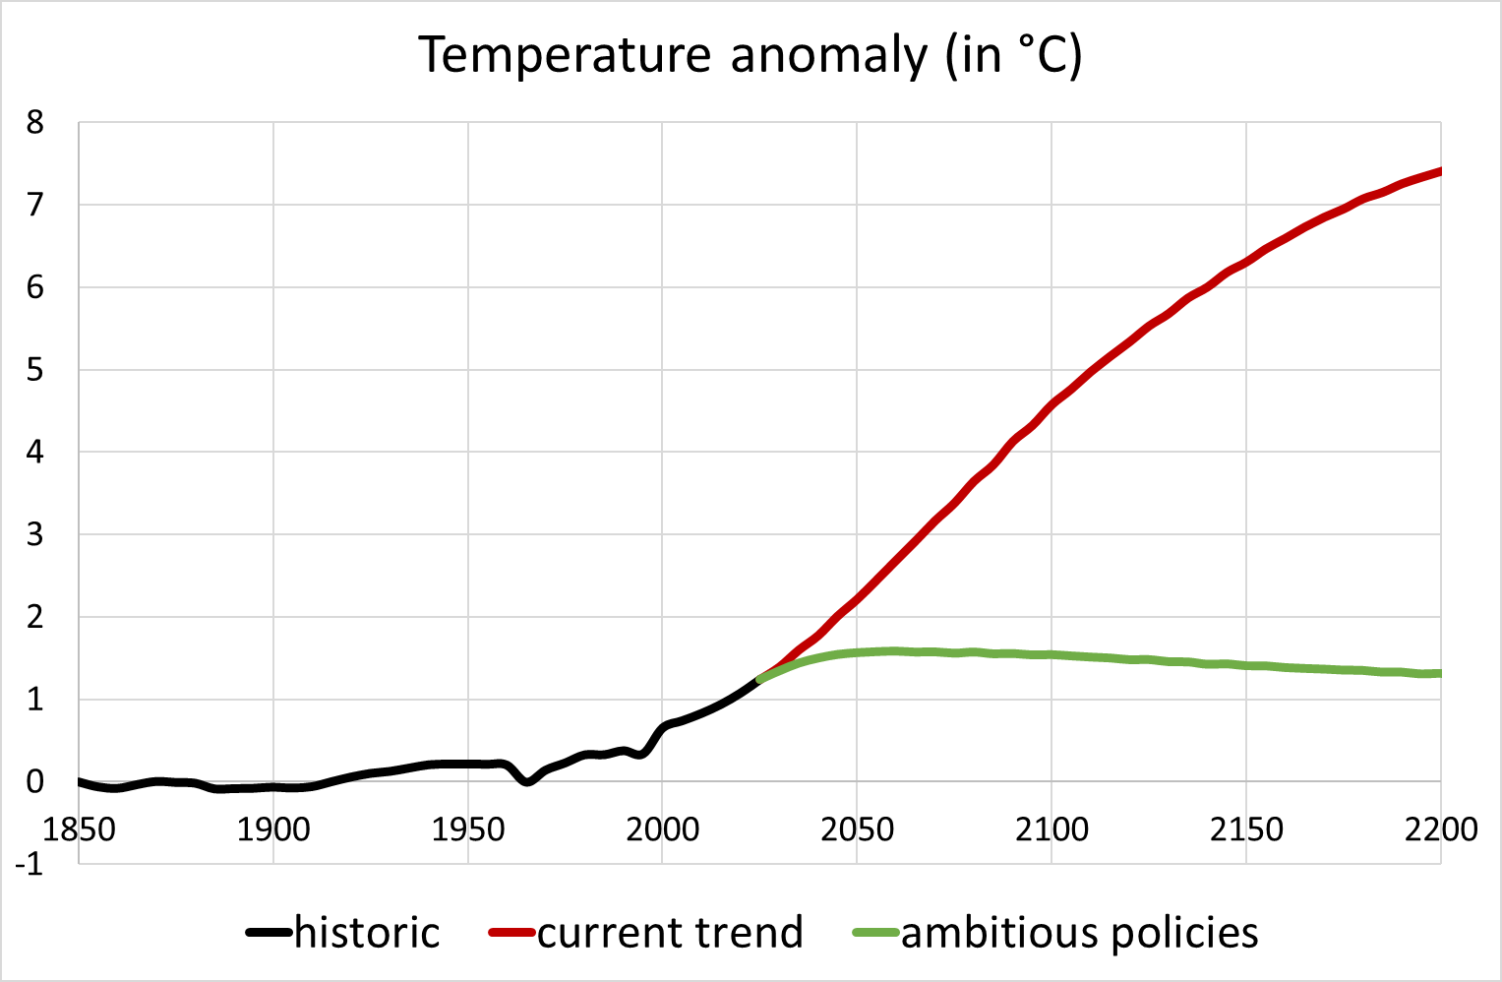

Source: Meinshausen et al. (2011) https://link.springer.com/article/10.1007/s10584-011-0156-z

There is also a version of this graph in French and in °F

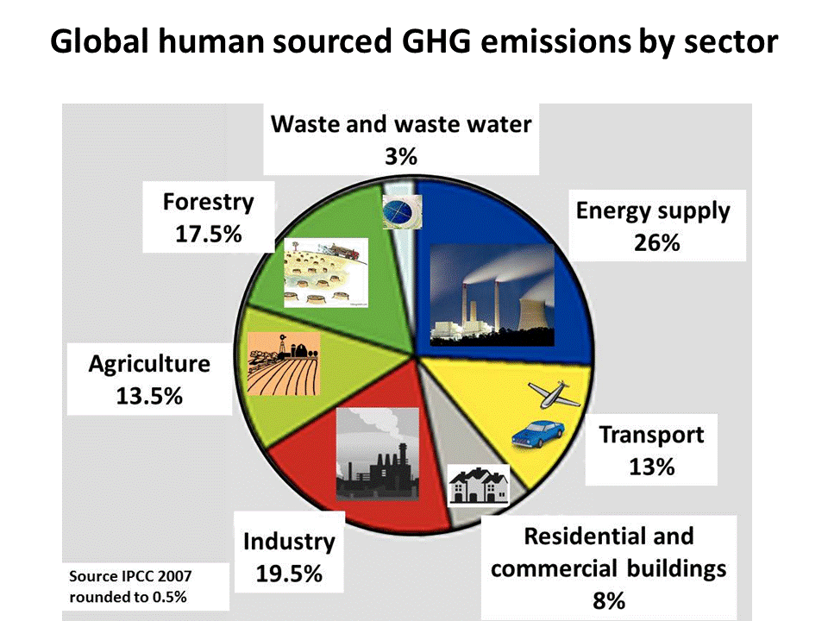

Source: https://i.pinimg.com/originals/28/f0/72/28f07273a64c12a313c3ad49ab8e5bae.gif